How-To Create Booklets Using Microsoft Word 2010
By Austin Krause on January 8, 2010 in Microsoft
Whether you are working on a school project or creating advertising materials, a decent booklet can come in handy and inspire the wow factor with the un-groovy! Using Microsoft Word 2010, you can create professional looking booklets and print them out yourself (assuming you have a decent printer) with just a few simple clicks. It’s that simple.
Honestly, the only real work is coming up with the content as Word will automatically print each page in the correct order on the correct placement on the paper. Before you get booklet fever and go on a creative spree, first we need to set up the page layout. Using booklet mode, Word 2010 will essentially shrink each page as if it’s being folded in half. We’ll talk more about the layout in step 3 below. Let’s get started!

How-To Create Booklets Using Microsoft Word 2010
1. Click File, then Print and at the bottom of the list Click Page Setup.
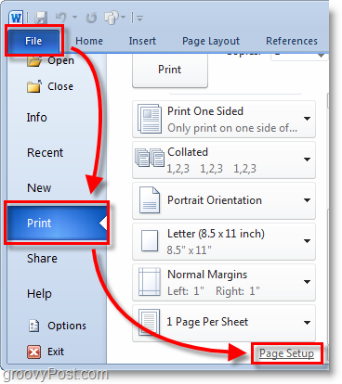
2. In the Page Setup window, Click the Margins tab. Then under Multiple pages Select Book fold from the drop menu. Under Sheets either Select All or the exact amount of pages you plan on having. Be sure to set the gutter to Set the Gutter to a small margin. The gutter determines the space between your page content and the fold in the middle of the paper where you would normally bind pages together.
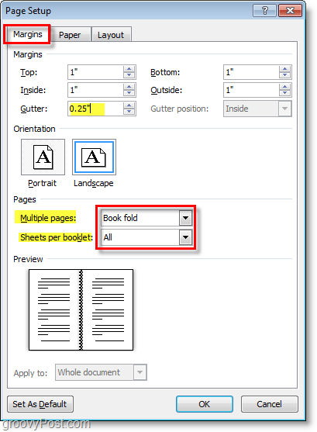
3. Create your booklet content, keep in mind that content is going to be printed differently than a normal document. Page 1 and 4 will be printed on the same side, as Page 2 and 3 will be on the opposite side. Each page size will be shrunk to the size of half of normal page in landscape mode. The image below should help illustrate.
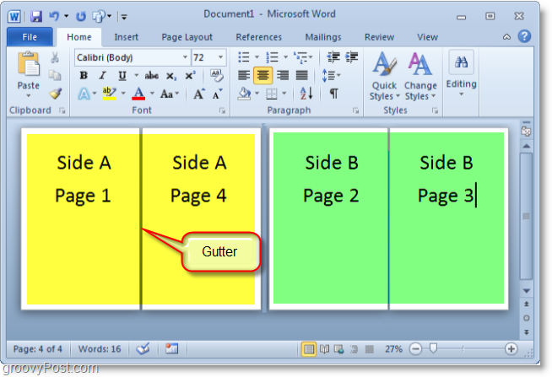
4. When you are ready to print Click File then Print and change the printing preference to the correct setting for your printer. If your printer can automatically re-feed itself printed documents then use one of the Print on Both Sides settings, but if your printer requires you to manually re-insert your paper Select Manually Print on Both Sides.
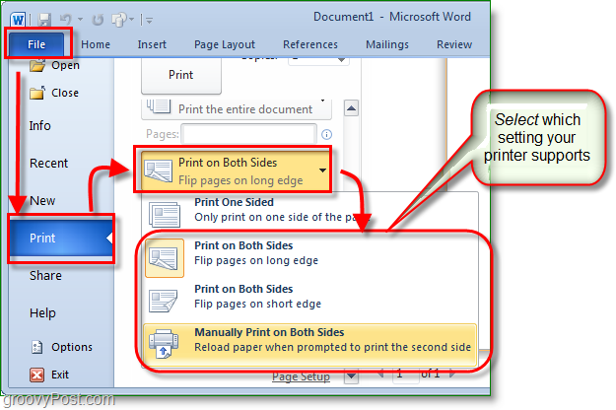
Now you can continue adding pages and design your booklet to be as large as you like! Don’t forget that the larger you make your booklet the larger you’ll need to make the Gutter so page content doesn’t get lost in the cracks when you bind them together.
