Creating a Brochure
Open Publisher 2007
Start > All Programs > Microsoft Office > Publisher
- In “Popular Publication Types” click on Brochures
- Select “Arrows” under “Newer Designs”
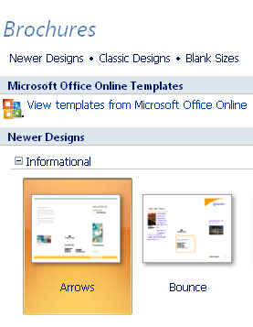
- On the right side of the screen under “Options” pick 3 panels.
You can pick 3 or 4 panels for future brochures.
- Click on “Create” located under “Options”
Customize Template
The design you selected for the brochure will appear. Click on all textboxes and pictures, white dots appear at the corners, and delete them one at a time. Do this for both side 1 and 2. You will end up with an empty template.
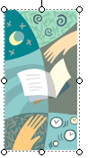
Creating Text Boxes
Insert your textboxes, on side 1 and 2, to create your own template.
1. Click on text box icon or go to tool bar > insert > text box.
Move the cursor to template, + sign will appear, move the + sign
to where you want the text box to start, click
and drag outward to create a text box.
2. Move the text box to a different the location:
Click on the text box so the white dots appear, click on a line of
the text box and move it.
3. Change the size of the text box:
Click on the text box so the white dots appear, drag one of the
dots outward to increase the size or drag it in to decrease the
size.
4. Make copies of the text boxes:
Click on the text box you want to copy so the white dots appear at
the corners, go to the tool bar > Edit > Copy > Edit > Paste and move
copied text box to the desired location.
Short cut – Ctrl + C for copy and Ctrl + V for paste
Short cut - right click your mouse and select copy or paste

5. Create your template so it looks like the example below.
Side 1 Side 2
6. Change between side 1 and side 2 click on the tools 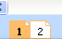 located at the bottom of the screen. The number in orange is the side you are working on. Side 1 is the outside of the brochure and side 2 is the inside.
Putting Information in Brochure
1. Open documents “Pictures” and “Text”.
Copy, paste and arrange this information in your brochure.
Use “Edmonds Brochure” link as an example of how to arrange
the information.
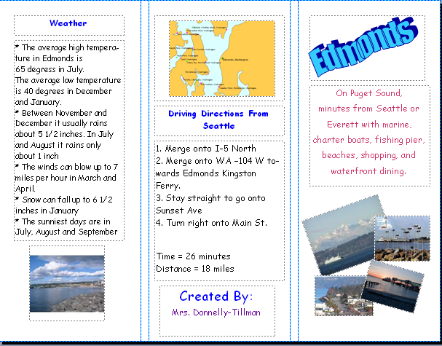 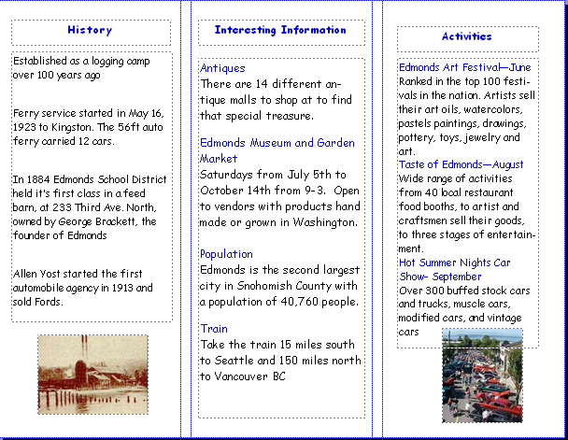
Font
Change font from Comic Sans and size so the information
fills the text boxes and change the font color.
Turn pictures
Click on the picture and turn it using the green dot at the top.
Hoover your curser over the green dot and turn the picture.
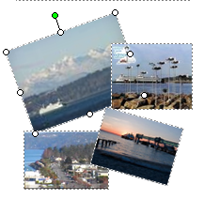
Overlap pictures
Click on picture, click on “Arrange” in tool bar, scroll down to
“Order” and select “Bring to Front” or “Send to Back”
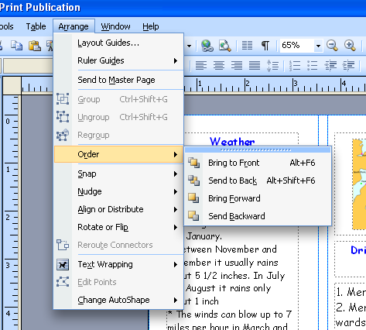
Insert Pictures
Insert > Pictures > Clip Art or From File
Pick “Clip Art” to use pictures that comes with Publisher
Pick “From File” to use pictures that you saved on your computer from the Internet or digital camera. Follow the browser prompts to identify the picture to use in the brochure.
Once the picture in inserted in the brochure you can move and resize it.
To move the picture, click on it and drag to the new location.
To resize the picture, click on one of the white dots on the corner of the picture and drag it in or out.

Word Art
Click on Word Art icon.

Select the style, click OK, type name of city, pick font and size
and click OK. Move the city name to the text box in the upper
right corner.
