[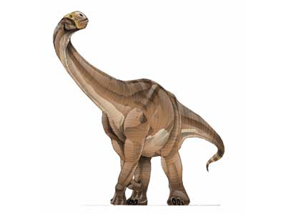](http://www.yahooligans.com/content/science/dinosaurs/dino_card/91.html)

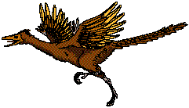

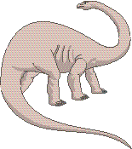[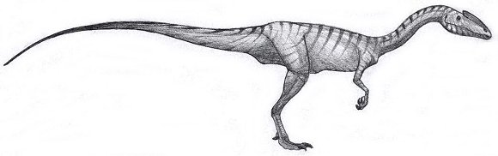](javascript:history.back())

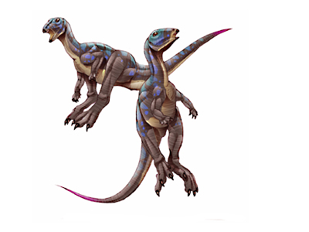

Archaeopteryx

Cetiosaurus



Syntarsus

Middle – Dogger

180 – 154

One Million Years Ago

Brachiosaurus

Xiaosaurus

Ichthyosaurus

Late – Malm

154 – 144

Million Years Ago

Early - Lias

206 – 180

One Million Years Ago